Ideation Phase
India's Agricultural Crop Production Analysis
Project Title | India's Agricultural Crop Production Analysis
Domain | Agriculture / Data Analytics & Business Intelligence
Tool | Tableau Desktop / Tableau Public
Dataset | Historical Indian Crop Production Data, 1997–2021
Prepared By | Divya Kauluri (Team Project — completed individually; the team lead and other assigned members did not contribute to the work)
Mentor | [Not yet assigned / add name]
GitHub Repository | https://github.com/divyakauluri-spec/India-s-agricultural-crop-production-analysis
Tableau Public Link | https://public.tableau.com/app/profile/divya.kauluri/viz/IndiaAgricultureanalysisproject
Date | 02/07/2026

1.1 Problem Statement
The following problem statements were derived from the two primary user personas identified for this project.
Field | Persona 1 — Rajesh (Farmer) | Persona 2 — Ananya (Policy Analyst)
I am (Customer) | A small-scale farmer in Uttar Pradesh with limited access to agricultural data | A government policy analyst at the Ministry of Agriculture responsible for policy design
I'm trying to… | Decide which crops to grow each season to maximize yield and income | Identify regions with low crop yield and understand long-term production trends to allocate resources
But… | I don't have access to historical crop performance data for my region or season | Data is fragmented across departments and not visualized in a way that supports quick policy decisions
Because… | Agricultural data is complex, scattered across government reports, and not presented visually | Government datasets lack interactive visualization tools that allow drill-down by state, season, and year
Which makes me feel… | Anxious, uncertain about my income, and forced to rely on guesswork and tradition | Frustrated and unable to confidently justify resource allocation decisions with data evidence
Key Takeaway
Both personas are blocked by the same root cause: agricultural data exists but is not accessible or visual. Rajesh cannot see multi-year trends for his own district, and Ananya cannot compare regions quickly enough to act on them. This shared root cause is what justifies a single Tableau solution serving both audiences (and, by extension, Vikram the investor) rather than building separate tools for each persona.
Why a Shared Root Cause Matters for Scope
A recurring risk in dashboard projects is scope creep driven by trying to serve every persona with a bespoke tool. By identifying early that Rajesh and Ananya's frustrations trace back to the same underlying gap — data that is collected but never made visual or filterable — the project could commit to one shared data model and one published workbook, with role-specific dashboards layered on top rather than three disconnected applications. This decision, made at the ideation stage, is what kept the later Requirement Analysis and Design phases from splintering into three parallel mini-projects.
Cross-Referencing the Two Personas
Reading the two persona columns side by side reveals both overlap and distinct emphasis:
• Shared pain: neither persona can currently answer “what happened in past years?” without manually digging through government PDF or spreadsheet reports.
• Shared emotional state: both describe a feeling of low confidence — Rajesh's is framed as personal anxiety about income, Ananya's as professional frustration at being unable to justify decisions with evidence.
• Distinct granularity need: Rajesh needs district- and season-level detail for one region, while Ananya needs state-level and national-level comparison across many regions at once. This distinction is precisely why the final workbook was built with both a Farmer's View (narrow, seasonal) and a Policy Analyst's View (broad, regional) rather than one generic dashboard trying to serve both.
• Distinct time horizon: Rajesh thinks in terms of the next one or two growing seasons, while Ananya is evaluating decade-long trends to justify multi-year policy investment — which is why the Trend of Agricultural Yield chart (Section 6.5) was built to span the full 1997–2021 window rather than a single recent year.
Validating the Problem Before Building
Before any wireframe or chart was designed, this problem statement exercise was used as a gate: every worksheet added later in Section 6.5 of the Final Report had to trace back to at least one row in this table. Charts that could not be justified against a stated persona pain point — for example, a purely decorative crop icon gallery that was considered early on — were dropped before development began, keeping the eventual nine-chart, four-dashboard workbook focused rather than bloated.

1.2 Empathy Map Canvas — Rajesh (Small-Scale Farmer)

Dimension | Content
SAYS | "I always plant what my father planted." | "I wish I knew which crops grow best near my district." | "The market price changes every season and I never know what to expect."
THINKS | "Which crop will give me the best return this Kharif season?" | "Is the weather pattern changing how my region performs?" | "Am I missing out on more profitable crops that others are growing?"
DOES | Relies on word-of-mouth advice from neighboring farmers | Follows traditional cropping calendars | Makes planting decisions based on limited local observation and experience
FEELS | Anxious about unpredictable yields | Frustrated by lack of reliable, region-specific data | Hopeful that technology could help reduce his financial risk
PAINS | No access to historical, region-specific crop performance data | Cannot compare seasonal outcomes across years | Limited ability to visualize trends or identify high-performing crops
GAINS (What Success Looks Like) | Clear visual insight into which crops perform best in his state and season | Confidence in crop selection decisions | Reduced financial risk and improved income stability
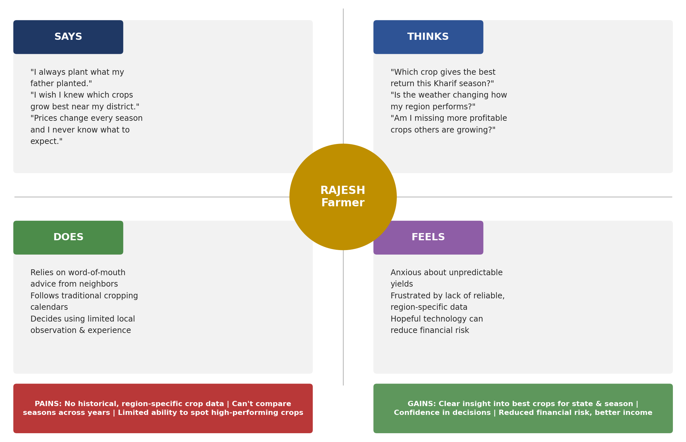
Figure 1.1 — Empathy Map Canvas for Rajesh, visualized

What the Empathy Map Shows
The canvas surfaces a consistent pattern across all four quadrants: Rajesh SAYS he wants better crop choices, THINKS the government has data he can't reach, FEELS anxious about unpredictable income, and DOES rely on neighbours and tradition instead of evidence. The pain points (inaccessible data, low digital literacy, no visual tools) map directly onto the functional requirements defined later in Section 2.2, while the gains he's seeking (confidence, predictability, higher yield) became the success criteria used to judge the final dashboard.
Quadrant-by-Quadrant Breakdown
• Says: Rajesh voices a desire to know “which crop will actually pay off this season,” and openly admits that he currently picks crops based on what his neighbours grew last year rather than any regional yield data.
• Thinks: he assumes that state agriculture departments must already track this information, but has no way to access it himself — a belief that turned out to be accurate, since the underlying government crop production dataset used in this project does exist but is only distributed as raw, unfiltered spreadsheets.
• Feels: the dominant emotion is anxiety tied directly to income unpredictability, compounded by a sense of being left behind by more “data-literate” large-scale farms and agribusinesses.
• Does: in practice, Rajesh's actual behaviour is to ask around locally, follow tradition, and occasionally consult a local agricultural extension officer — none of which scale to district-wide, multi-year evidence.
Pains vs. Gains
The pains — inaccessible data, no visual tools, low confidence in decisions — sit in direct opposition to the gains he is seeking: a simple, filterable view of season and crop performance, presented in a way that does not require spreadsheet or statistics literacy. This pains-to-gains mapping is what shaped two concrete design decisions carried through to the final workbook: (1) the Farmer's View dashboard (Section 6.5) intentionally uses only three charts — Season-wise Production, Trend of Agricultural Yield, and Cultivated Area by Crop — rather than the full nine-chart set, to avoid overwhelming a first-time dashboard user; and (2) every chart uses plain axis labels and a title stating the insight in plain language rather than technical field names.
Why This Persona Was Prioritized First
Of the three personas identified in the Problem Statement, Rajesh was chosen for the first empathy map because his constraints (limited data literacy, mobile-first access, single-region focus) are the most restrictive of the three. Designing for his constraints first, and then relaxing them for Ananya (who is comfortable with denser regional comparisons) and Vikram (who wants growth-oriented, multi-year views), followed a “design for the hardest case first” approach that kept the eventual dashboard set usable for all three without requiring three entirely separate visual languages.

1.3 Brainstorming, Idea Generation & Prioritization

Step 1 — Problem Selection
I reviewed the three user personas (Rajesh, Ananya, Vikram) and identified that the core unmet need across all three was the absence of a unified, visual, interactive tool for exploring India's historical crop production data. I selected the problem: 'How can I empower farmers, policy analysts, and investors to make data-driven agricultural decisions using historical production data from 1997–2021?'

Step 2 — Idea Listing & Grouping
- Build state-wise and district-wise production maps to show regional variation
- Create seasonal trend charts (Kharif vs Rabi vs Whole Year vs others)
- Develop year-over-year line charts to show production growth or decline
- Build crop-wise treemaps to show relative crop importance by volume
- Design role-specific dashboards for the Farmer, Policy Analyst, and Investor personas
- Combine all dashboards into a Tableau Story for narrative-driven presentation
- Publish to Tableau Public for free, browser-accessible sharing

Step 3 — Idea Prioritization

Idea | Impact | Feasibility | Priority
State-wise production map | High | High | 1
Year-wise trend line chart | High | High | 2
Top 10 crops bar chart | High | High | 3
Season-wise distribution chart | Medium | High | 4
Crop-wise treemap | Medium | High | 5
Role-specific dashboards (3) | High | Medium | 6
Tableau Story (narrative) | Medium | Medium | 7
Publish to Tableau Public | High | High | 8

